WEEK 8 — Observability & Cost (Capstone)
**Name:** Amrish Kumar
**Azure Region:** East US
**App Type:** Java App (Azure App Service)
**Subscription:** Microsoft Azure Sponsorship

1. Objective
This lab focuses on implementing observability and cost monitoring for a deployed Java App on Azure App Service. The tasks include enabling telemetry using Application Insights, creating alerts, and simulating cost monitoring through the Azure Sponsorship portal.

2. Create App Service
1. Log in to the Azure Portal (https://portal.azure.com).
2. Search for 'App Services' and click 'Create'.
3. Select Subscription and Resource Group (e.g., yc-18122).
4. Name your app service (e.g., amrish-app).
5. Publish: Code | Runtime stack: Java | OS: Linux | Region: East US.
6. Choose App Service Plan: Basic or Standard (Free).
7. Click 'Review + Create' → 'Create'.

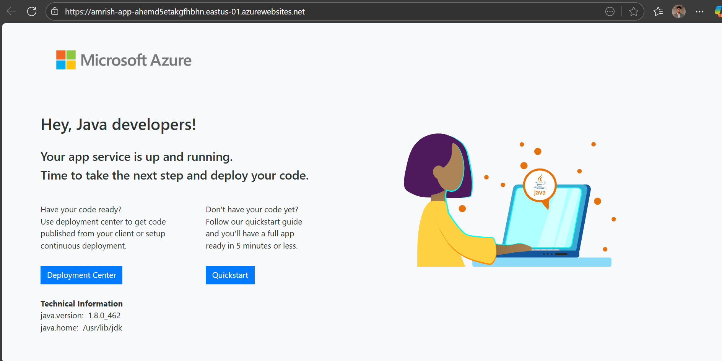
App Service Creation Confirmation
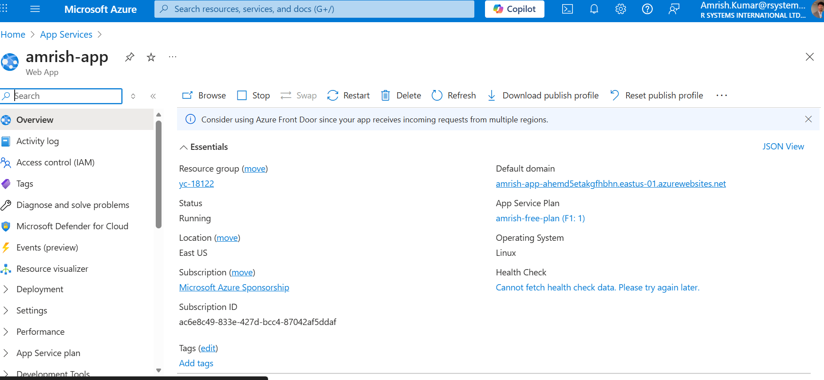

3. Enable Application Insights
1. In your App Service, open 'Application Insights' from the left menu.
2. Click 'Turn on Application Insights'.
3. Select 'Create New Resource' and keep the same region (East US).
4. Click 'Apply'.
Application Insights will start collecting telemetry such as requests, failures, dependencies, and response times.
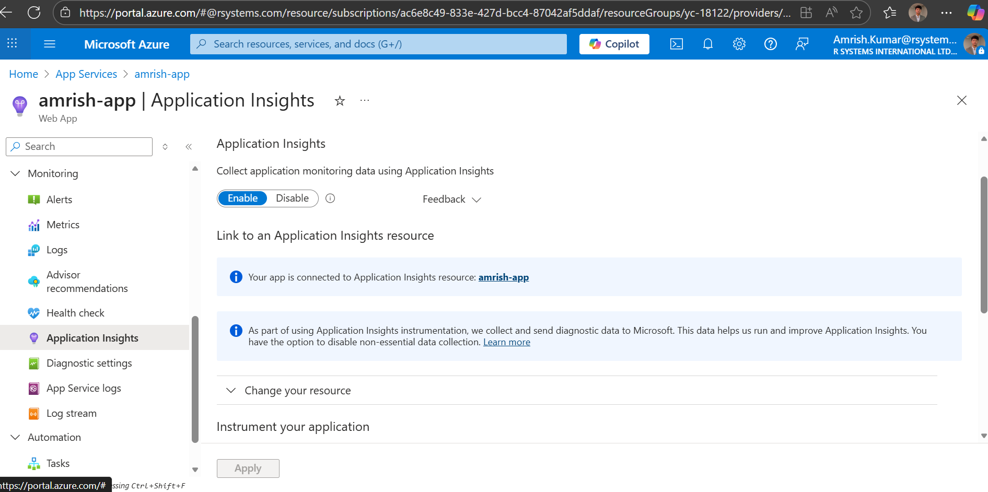

4. View Logs and Metrics
1. Go to 'Log Stream' under Monitoring to view real-time logs.
2. To view telemetry data, go to 'Application Insights → Logs'.
3. Run a simple KQL query:
requests | order by timestamp desc | take 10
4. You can also view metrics under 'Metrics' → CPU Time, Memory, or Request count.
Metrics or Log Query Result
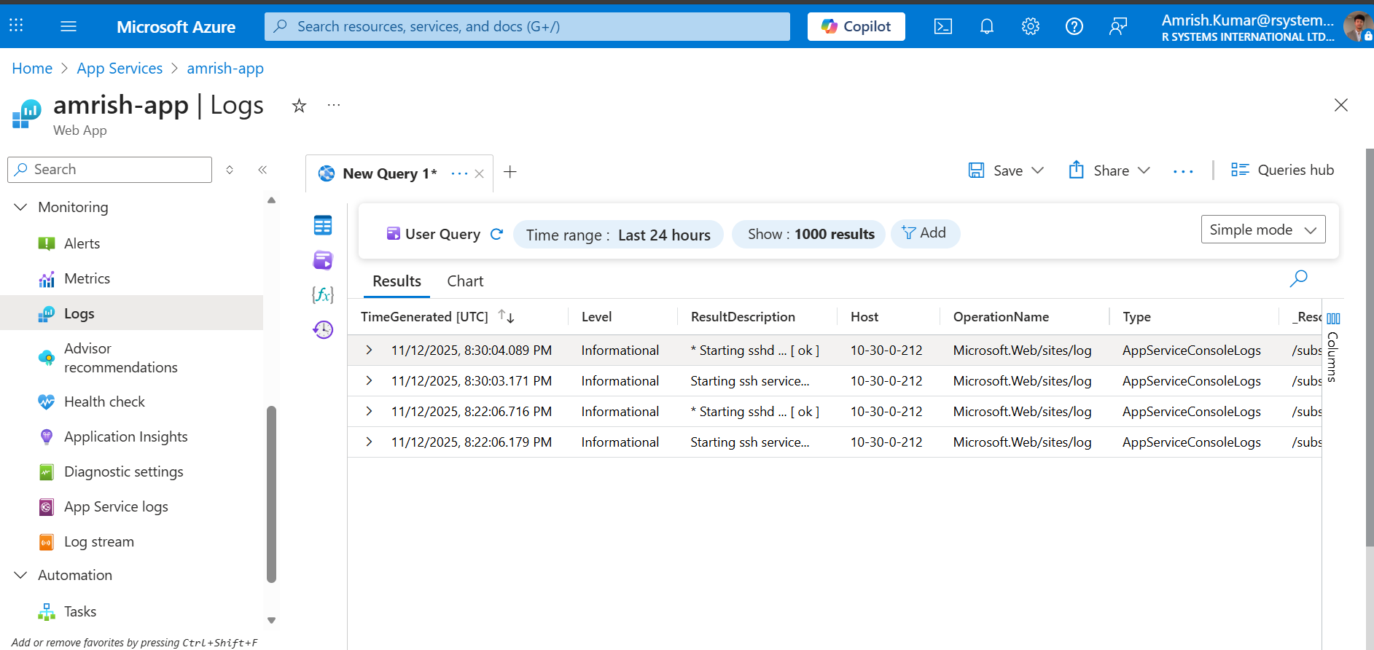

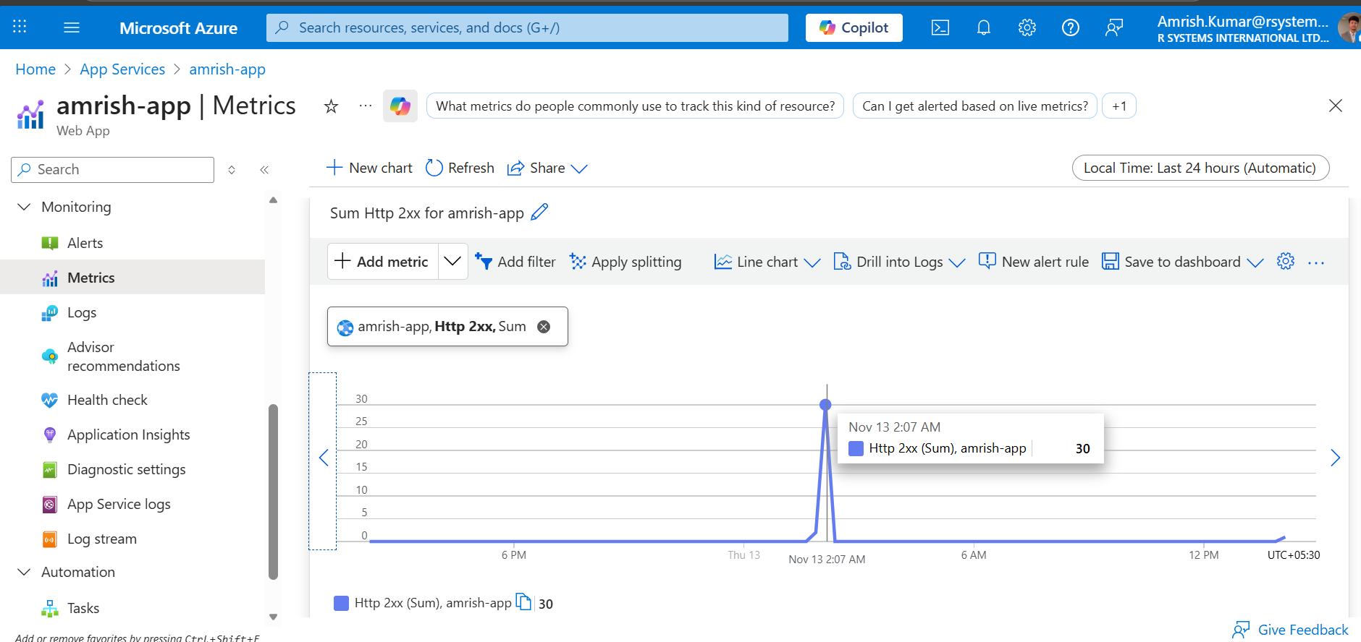

5. Create Alerts
1. Navigate to 'App Service → Alerts → Create Alert Rule'.
2. Scope: Select your App Service.
3. Condition: Choose metric 'CPU Time' (for Basic Plan) or 'CPU Percentage' (for Standard Plan).
4. Set threshold: e.g., CPU Time > 60 seconds in 5 minutes.
5. Create a new Action Group → Add your email.
6. Save the alert rule.
[📸 Screenshot Placeholder: Alert Rule Creation Screen]

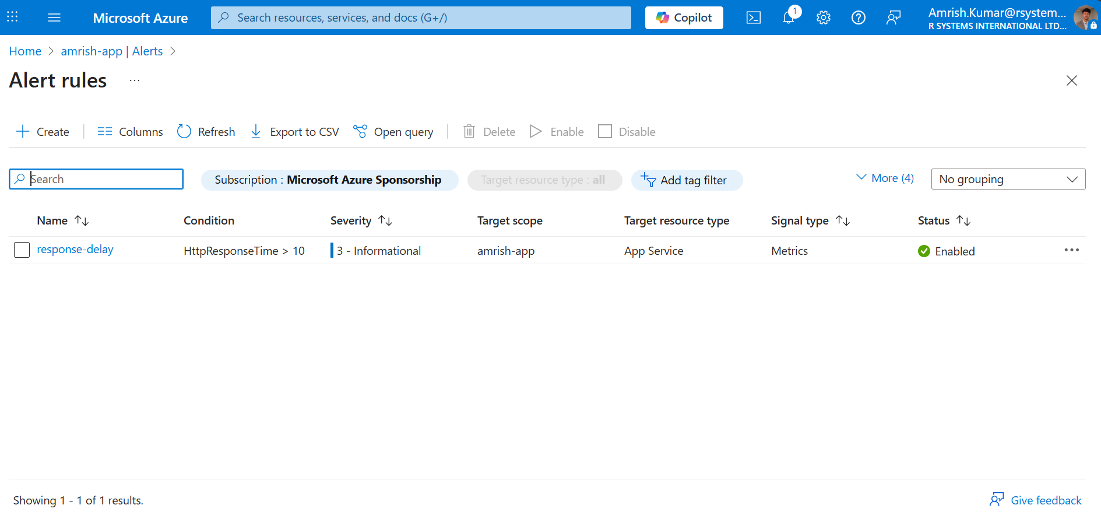

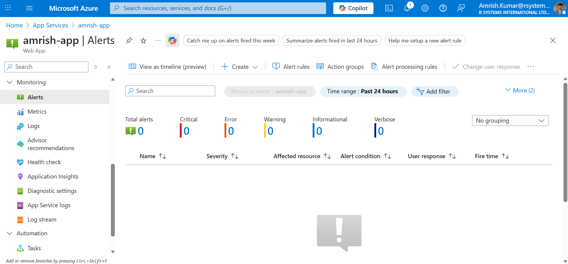

6. Simulate Budget Monitoring (Sponsorship Account)
Since the Azure Sponsorship subscription does not support Cost Management + Budgets directly, the cost and credit usage can be monitored using the Azure Sponsorship portal.
Steps:
1. Visit https://www.microsoftazuresponsorships.com/
2. Log in with your Azure account.
3. Review remaining credits, usage history, and expiry details.
[📸 Screenshot Placeholder: Sponsorship Portal Dashboard]

7. Capstone Integration
As part of the capstone, the end-to-end app includes:
- Azure Blob ($web) for static content
- Azure Key Vault for secrets
- Azure App Service for hosting the Java application
- Application Insights for observability
- Alerts via Azure Monitor
- Cost tracking via Sponsorship Portal

8. Learning Outcomes
- Understood difference between App Service (PaaS) and VMs (IaaS).
- Learned how to enable and use Application Insights for telemetry.
- Configured metric-based alerts for performance monitoring.
- Simulated cost monitoring using Azure Sponsorship portal.
- Gained insight into observability practices using Azure Monitor and KQL.

9. Runbook (Deploy & Rollback)
• **Deploy:**
- Upload new Java WAR/JAR file via Deployment Center.
- Verify deployment via App Service URL.
- Monitor Application Insights for telemetry.
• **Rollback:**
- Re-deploy the previous working build (stored in CI/CD or local backup).
- Verify the previous version is live and stable.

